January 13, 2020

Dear Respective Members of the Legislative Assembly,
On behalf of the Saskatchewan Heavy Construction Association and its members, thank you in advance for taking the time to hear our concerns regarding the single-window procurement process.
Our dissatisfaction with this issue is nothing new and frustrations are mounting.
It is our understanding that the ideology behind single-window procurement was to streamline processes which would enable greater efficiency and smoother operations. That’s not happening. In fact, this added layer in the process has created unnecessary delays in tenders being awarded to our members.
An example of this saw one of our members waiting 27 days before he received a response for a job on which he bid. This is unheard of in our industry. On average, the process is taking 10-15 days.
These delays challenges crews when it comes to finishing dates for jobs originally proposed on tenders. Furthermore, the unpredictable winter weather complicates the timing, as machinery cannot operate when temperatures plunge.
Our contractors are feeling pinched. The delay places them at a disadvantage as they deal with the balancing act of over-promising and under-delivering on jobs.
Without question, this procurement process requires swift improvements.
Our recommendation is simple – consultation.
We respect the fact that this team specializes in procurement procedures and we appreciate the attempts it has made to repair a system that appears broken.
However, their inexperience in road building and construction and the subsequent delays is impacting the greater business community.
We as an association welcome consultation and we are available to offer input and suggestions to how we can improve operations. Good communications and consultation are central to the management process and assume critical importance when dealing with changes in working practices and procedures.
…./2
Effective consultation would allow the procurement team and our association to voice concerns and hopefully find common ground that would resolve this issue.
We are asking for accountability from our government that projects are awarded in timely fashion. After all, our members are expected to present their bids before the tender closing dates.
We thank you for your interest in resolving this issue and look forward to hearing from you soon regarding consultation.
Sincerely,
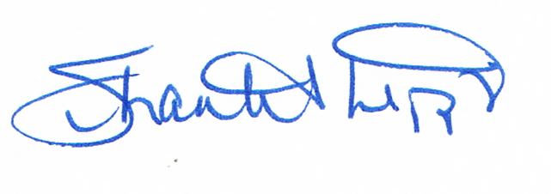
Shantel Lipp
President
Saskatchewan Heavy Construction Association

